# Abstract

Driver drowsiness detection is a car safety technology which helps prevent accidents caused by the driver getting drowsy. Various studies have suggested that around 20% of all road accidents are fatigue-related, up to 50% on certain roads. The drowsiness detection system is capable of detecting drowsiness quickly. The driver behaviors are noticed in many conditions such as wearing spectacles and also in the dark condition inside the vehicle. The system is capable of detecting the drowsiness condition within the duration of more than two seconds. After the detection of abnormal behaviors, it is alerted to the driver through alarms and the parking lights will be on that will stop the vehicle which reduces the accidents due to drowsiness of the driver. A deep learning Architecture detects the face and eyes, based on the status of the eyes. If the eyes are closed more than usual time, it generates an alarm, intimating the driver. Neglecting our duties towards safer travel has enabled hundreds of thousands of tragedies to get associated with this wonderful invention every year. In order to monitor and prevent a destructive outcome from such negligence, many researchers have written research papers on driver drowsiness detection systems. But at times, some of the points and observations made by the system are not accurate enough. Hence, to provide data and another perspective on the problem at hand, in order to improve their implementations and to further optimize the solution, this project has been done.

**CHAPTER 1**

**INTRODUCTION**

# Introduction

In the realm of road safety, the menace of driver drowsiness has become a critical concern, contributing substantially to traffic accidents globally. The imperative to combat this issue has led to the development of an innovative solution – the Driver Drowsiness Detection System (DDDS). This system, integrating cutting-edge technologies such as machine learning and computer vision, seeks to proactively identify signs of driver drowsiness in real-time.

The DDDS employs a non-intrusive approach, utilizing a strategically positioned camera within the vehicle to continuously monitor the driver's facial features and behaviors. Through sophisticated computer vision algorithms, the system analyses parameters like eye closure, head movements, and facial expressions, crucial indicators of drowsiness. These real-time data are then processed by a machine learning model, trained on diverse datasets, enabling the system to recognize and respond to patterns associated with drowsiness.

Ensuring a seamless integration into the driving experience, the DDDS operates without causing disruption to the driver's activities. The system collaborates harmoniously with the vehicle's alert mechanisms, delivering timely warnings through visual and auditory cues when drowsiness is detected. Furthermore, adaptive learning techniques are incorporated, allowing the DDDS to adapt and improve its accuracy over time, tailoring its responses to individual driver behaviors.

*As road safety remains a paramount concern, the development and implementation of an effective DDDS stand as a pivotal step towards mitigating the risks of drowsy driving. By actively alerting drivers to signs of fatigue, the system aims to contribute significantly to the reduction of accidents caused by drowsiness, thereby enhancing overall road safety and saving lives.

# Motivation of the project

Driver drowsiness is a significant factor in the increasing number of accidents on today’s roads and has been extensively accepted. This proof has been verified by many researchers that have demonstrated ties between driver drowsiness and road accidents. Although it is hard to decide the exact number of accidents due to drowsiness, it is much likely to be underestimated. The above statement shows the significance of a research with the objective of reducing the dangers of accidents anticipated to drowsiness. so far, researchers have tried to model the behavior by creating links between drowsiness and certain indications related to the vehicle and to the driver. Previous approaches to drowsiness detection primarily make pre- assumptions about the relevant behavior, focusing on blink rate, eye closure, and yawning. The automobile business also has tried to build several systems to predict driver drowsiness but there are only a few commercial products available today. The systems do not look at driver performance and overlook driver ability and characteristics. Naturally, most people would agree that different people drive differently. The system that being develop able to adapt to the changes of the driver’s behavior.

# Problem Definition

The number of accidents on the road due to drowsiness is very high. Drowsiness Detection is the detection of a person to check whether the person is feeling sleepy while performing a significant task. This detection has many applications in medical and safety fields.

**CHAPTER 2**

**LITERATURE SURVEY**

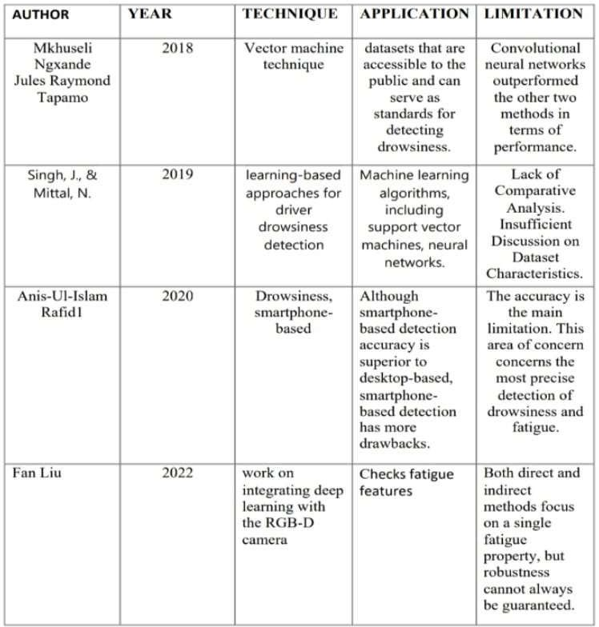

Fig 2.1 Literature Survey

# Existing System

Non-intrusive machine vision-based concepts are used to develop drowsiness for the driver detected system. Numerous existing systems necessitate the installation of a front-facing camera. It looks into the driver's eyes and points directly at their face to detect drowsiness. Buses and heavy trucks, both of which are large vehicles, do not need this arrangement. The bus has a large glass window in the front for safe driving. Because it blocks the driver's frontal view, mounting a camera on the front glass is impractical. If the camera is mounted on the frame just above the window, it cannot accurately capture the driver's face from the front. The open CV detector only picks up 40% of the driver's face when they are in their normal driving position in a 10-minute video recording. In the oblique view, the Open CV eye detector (CV ED) frequently fails to locate the eyes. If the driver's eyes are closed for five frames in a row, the system will give them a warning. It then presumes that the driver isn't dozing. As a result, the current system is inapplicable to large vehicles. In this project, a new detection system is created to solve the issue with the current system.

Vision based techniques:

* + - No eye detection – most critical sign of drowsiness Yawning and nodding are not always practical. Varies from person to person – some may not yawn when they are sleepy sometimes.
    - Physiological sensors: More accurate solutions Needs to be attached to the human body
      * If driver forgets to wear it?
      * May hesitate to wear

Easy wear biosensors are developed.

* + - Head bands, headphones (Signal-Channel EEG)
    - Portal glasses for EOG
    - Hand bands for PPG

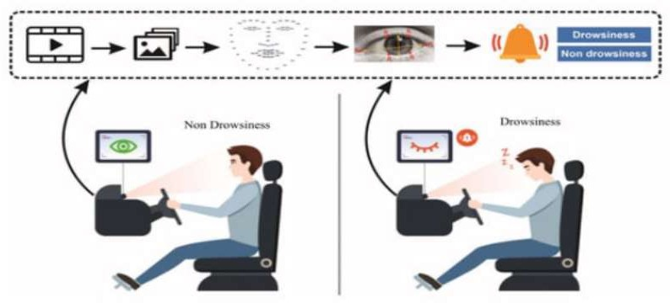

Fig 2.2 Existing system

# Proposed System

Method for detecting eyes:

The physiological properties and appearances of the eyes, in addition to the method of capturing these properties using infrared lighting, will be investigated. Kalman trackers will be utilized to decide eyes and head elements between progressive pictures and a probabilistic model will be utilized to compute the driver's cautiousness.

Path following identification calculation:

The behaviour of a driven vehicle is measured in relation to the vehicle's position in relation to its surroundings using image processing techniques

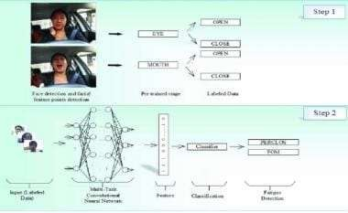

Fig 2.3 Path Following identification calculation

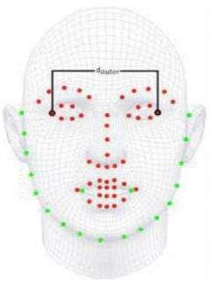

Fig 2.4 Landmark points

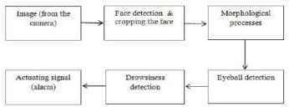

Fig 2.5 Working Model

# Objective of Proposed System:

1. Develop an Intelligent Monitoring System: - Create a Driver Drowsiness Detection System (DDDS) using advanced technologies like computer vision and machine learning.
2. Real-time Detection: - Enable the system to detect signs of drowsiness in real-time, providing timely alerts to the driver.
3. Facial Feature Analysis: - Utilize computer vision algorithms to analyse facial features, eye movements, and head pose for accurate drowsiness identification.
4. Non-Intrusive Operation: - Develop a system that operates non-intrusively to ensure minimal disruption to the driver's experience.
5. Alert Mechanism Integration: - Integrate with the vehicle's alert system to deliver visual and auditory cues when drowsiness is detected.
6. Adaptive Learning: - Incorporate adaptive learning techniques to tailor the system's responses to individual drivers, enhancing overall effectiveness.
7. Data Security and Privacy: - Implement robust data security measures to protect user privacy and comply with regulatory requirements.
8. User-friendly Interface: - Design a user-friendly interface for easy system configuration and understanding of alert notifications.
9. Evaluate and Validate System Performance: - Conduct thorough testing, simulations, and real-world evaluations to ensure the system's accuracy, reliability, and safety in diverse driving conditions.
10. Contribute to Road Safety: - Contribute to the reduction of accidents caused by drowsy driving, enhancing overall road safety and minimizing potential fatalities and injuries.

**CHAPTER 3**

**SYSTEM REQUIREMENTS SPECIFICATION**

# Hardware Requirements

The following are needed to efficiently use the application.

* + 1. Minimum of 2gb RAM
    2. 64bit Operating System
    3. Windows 7 or above3.2 Software Requirements

Software requirements define software resource fundamentals that need to be installed on a workstation to provide optimum working of a software. The following are required for optimal development and usage of the application.

1. Operating System: Windows 10, macOS, or Linux
2. Sensors
3. OpenCV
4. Imutils and Pygame
5. PySerial
6. IDE:Pycharm or Visual studio code
7. Web browser and internet connection

**CHAPTER 4**

**SYSTEM DESIGN**

# System Architecture

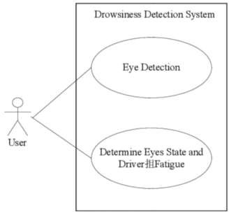

Fig 4.1: Use Case Diagram

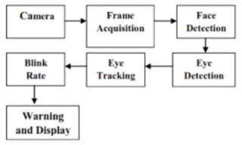

Fig 4.2 : Architecture of the system

Wake Watch AY-2023-2024

# Flowchart of Proposed System

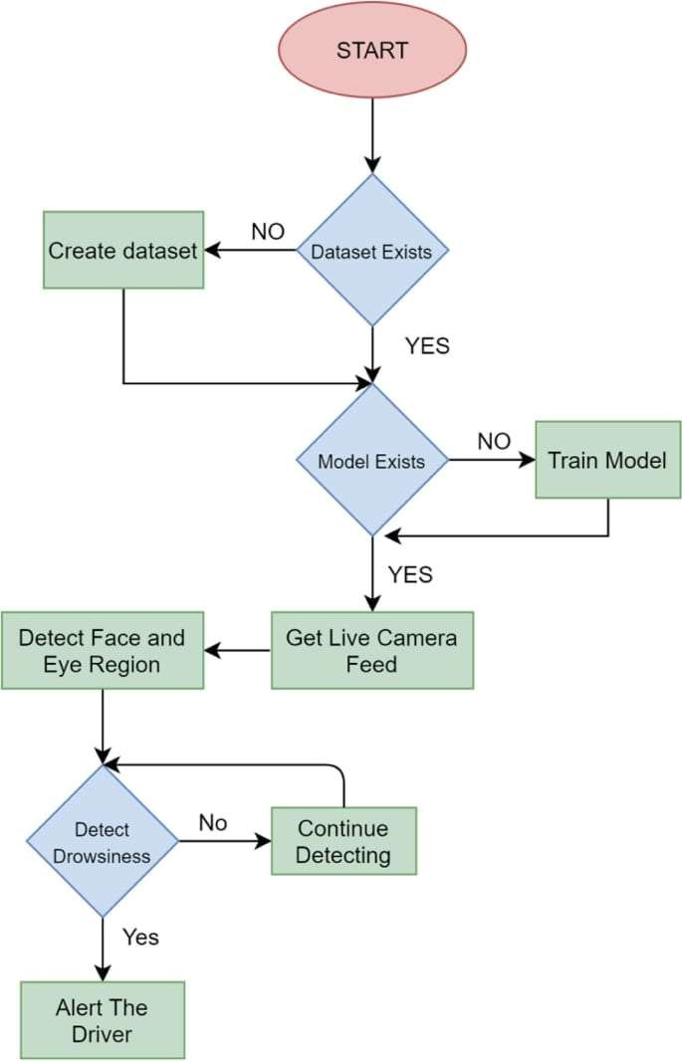

Fig 4.3: Flowchart of proposed system

**CHAPTER 5**

**IMPLEMENTATION**

# Code Implementation

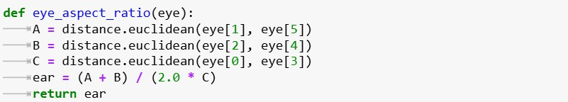

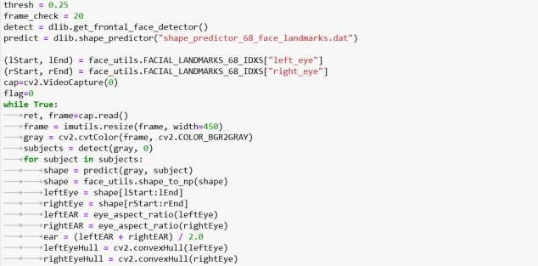

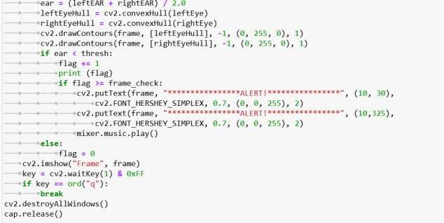

* 1. **Algorithm Steps**:
     + The overall algorithm is pretty straightforward one. First we have used a camera which is setup at a desirable position in a car that looks for a face stream.
     + If a face gets detected, the facial landmark detection task is applied and the region of eyes is extracted.
     + Once we get the eye region, we calculate the Eye Aspect Ratio to find out if the eye-lids are down for a substantial amount of time.
     + On the off chance that the Eye Aspect Ratio demonstrates that the eyes are shut for a considerably long measure of time, the alert will sound noisy to wake the driver up.For the functionalities of the system and to make it work efficiently we have used OpenCv, dlib and Python.
     + The implementation of the drowsiness detector system includes machine learning algorithms which are in turn included in OpenCv ML algorithms. There are numerous ML algorithms but for our purpose we required only the face detector algorithm.
     + It is fundamentally an item discovery ground-breaking application. Additionally, prepared frontal face identifier is accessible with the OpenCv circulation. It works efficiently well overall.
     + It can also be used to detect various different types of objects with the required software.

Facial landmarks and eye aspect ratio calculation :

* + - * For detecting and localising facial landmarks we will require the dlib library hence we import it. Eye_aspect_ratio function is defined to calculate the distance between the eye landmarks taken vertically and distances between the eye landmarks taken horizontally. 15 So, when the eye is open, the value returned for the eye aspect ratio will be a constant approximately. Then the value will rapidly decrease reaching zero in case of an eye blink. When the eye is closed, the eye aspect ratio again approaches an approximate constant value which is very small compared to that when the eye is open. Therefore, the dip in the aspect ratio indicates blink of the eyes.

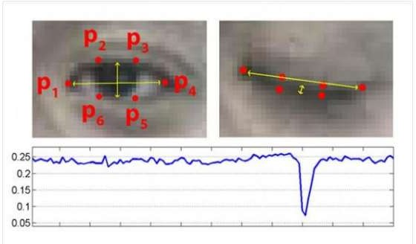

Fig 5.1 Plot of eye aspect ratio over time

**CHAPTER 6**

**EXPERIMENTAL RESULTS**

**6.1 OUTCOME**

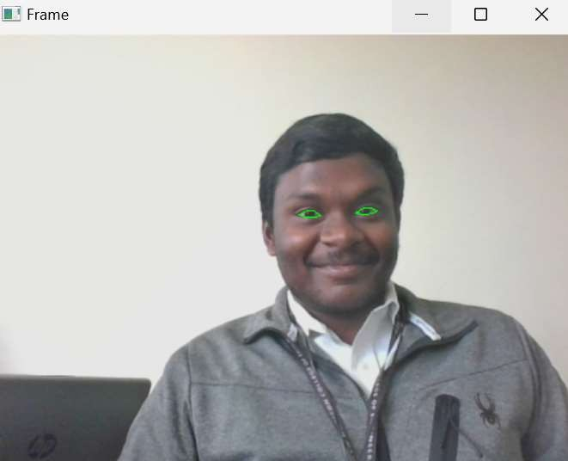

Fig 6.1 Mapping of eyes



Fig 6.2 Alert System

**CHAPTER 7**

**CONCLUSION AND FUTURE ENHANCEMENT**

# Conclusion

Wake-Watch system aims to significantly enhance automotive safety by addressing the critical issue of driver drowsiness. Through accurate drowsiness detection leveraging advanced signal processing and machine learning techniques, coupled with real-time alert mechanisms, the system proactively alerts drivers, mitigating the risks associated with fatigue-related accidents. The integration of GPS functionality ensures rapid emergency response capabilities, further bolstering the system's effectiveness in critical situations. Robust testing and validation protocols ensure reliability across diverse conditions, while prioritizing user interface clarity and data security fosters user trust and compliance with privacy standards. Scalable and modular design principles enable flexibility and future enhancements, ensuring the system's relevance and impact in promoting safer driving experiences.

In essence, the Wake-Watch project not only addresses current safety concerns but also sets a precedent for intelligent automotive safety systems that adapt to real-time driver conditions. By combining cutting-edge technology with user-centric design, the system aims to make significant strides in reducing accidents caused by driver drowsiness, ultimately contributing to safer roads and enhanced overall road safety standards.

# Future Enhancement

This framework can be stretched out further to have abundant security highlights, for example, just a certain no of individuals can have specialist get to or work the vehicle. If there should be an occurrence of an endeavor to robbery, the vehicle's motor don't begin or an alarm sounds The model can be improved incrementally by using other parameters like blink rate, yawning, state of the car, etc. If all these parameters are used it can improve the accuracy by a lot. We plan to further work on the project by adding a sensor to track the heart rate in order to prevent accidents caused due to sudden heart attacks to drivers. Same model and techniques can be used for various other uses like Netflix and other streaming services can detect when the user is asleep and stop the video accordingly. It can also be used in application that prevents user from sleeping.

Wake Watch AY-2023-2024

**REFERENCES**

1. Faisal Mohammad, Kausalendra Mahadas, George K. Hung, Drowsy driver mobile application: Development of a novel scleral-area detection method. Computers in Biology and Medicine, Vol.89, October 2017
2. Muhammad Tayeb Khan, Hafeez Anwar, Farhan Ullah, Ata Ur Rehman, Rehmat Ullah, Asif Iqbal, Bok-Hee Lee and Kyung Sup Kwak. “Smart Real-time Video Surveillance Platform for Drowsiness Detection Based on Eyelid Closure”, Wireless Communication and Mobile Computing, Volume 2019, Article ID 2036818, 9 pages,19 March 2019.
3. Hu, X.; Lodewijks, G. Detecting fatigue in car drivers and aircraft pilots by using non-invasive measures: The value of differentiation of sleepiness and mental fatigue. J..Saf. Res. 2020, 72, 173–187.
4. You, F.; Gong, Y.; Tu, H.; Liang, J.; Wang, H. A fatigue driving detection algorithm based on facial motion information entropy. J. Adv. Transp. 2020, 2020, 1–17
5. Zandi, A.S.; Quddus, A.; Prest, L.; Comeau, F.J. Non-intrusive detection of drowsy driving based on eye tracking data. Transp. Res. Rec. 2019, 2673, 247–257.
6. Drowsiness Detection Based On Driver Temporal Behaviour(31-March 2021, F. Faraji, F. Lotfi, J. Khorramdel, A. Najafi, A. Ghaffari).
7. A Survey on State of The Art Driver Drowsiness Detection Techniques(1 st December 2020, FHikmat Ullah Khan).
8. Driver Drowsiness Detection(21-09-2020, V B Navya Kiran, Raksha R, Anisoor Rahman, Varsha K N, Dr. Nagamani N P)
9. Driver Drowsiness Detection System(12 December 2019, Pratyush Agarwal)
10. Driver Drowsiness Detection System(May 2019,Muhammad Faique Shakeel and Nabita Bajwa